How to Add Reporting Services to an existing SQL Server Cluster Installation

http://www.sqldbaexperts.com/how-to-add-reporting-services-to-an-existing-sql-server-cluster-installation/?i=1
When we try to add SSRS on an existing SQL Server cluster instance, the install does not allow us to proceed after the Installation rule check page because one of the rules “Existing Cluster or Cluster-Prepared instance” fails during the rule check process.
Step 1: To add/install SSRS on an installed SQL Server Instance, we need to run setup again on each cluster node starting with active node. Follow all necessary steps in the setup windows. Make sure to run this setup to add SSRS on your existing instance rather than creating a new instance. Choose Reporting Services on the feature selection page of the setup window. After we start the install, we will get an error because one of the rules will fail as shown below.
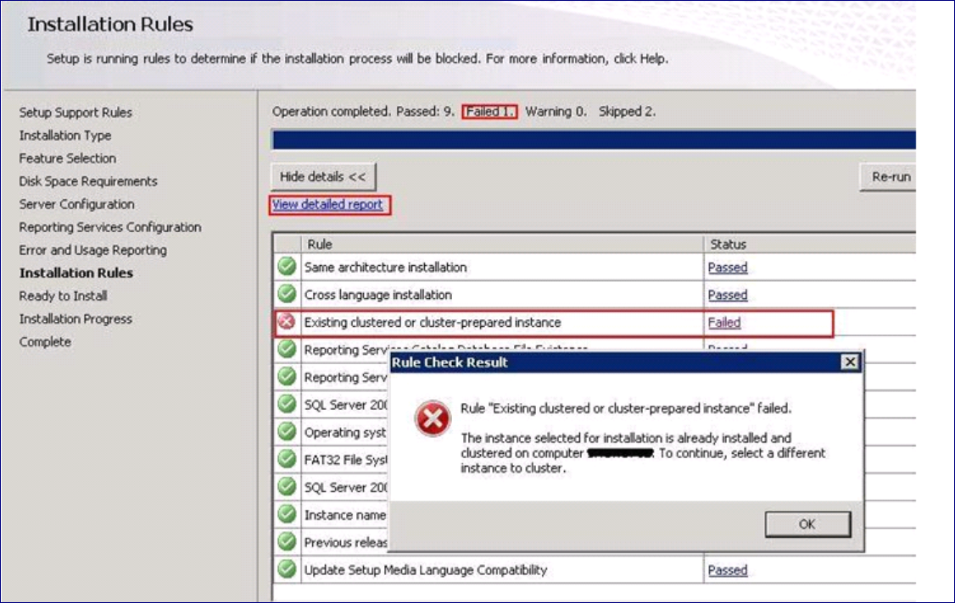
Step 2: When you get the above error, you cannot proceed with the install because the “Next” button will be disabled due to this failed rule.
One Solution is to install SSRS as a separate instance.
Another is to follow these steps to install on existing node.
Step 3: The solution is to run setup and skip the installation rules to install SQL Server Reporting Services in an existing clustered instance.
Run the below command at the Windows command prompt to start SQL Server setup on the active node. Make sure to run this command after changing the root directory of the command prompt to the location where you have placed the SQL Server setup files.
Setup.exe /SkipRules=StandaloneInstall_HasClusteredOrPreparedInstanceCheck /Action=Install

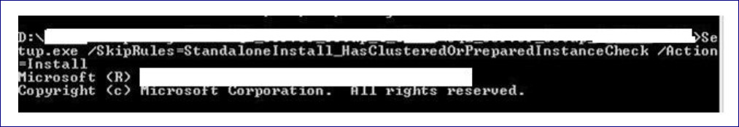

Now click on “Run program” to proceed with this installation.
Step 4: Now follow the same process which you normally do in an installation. Again choose the existing instance to add SSRS and select Reporting Services in the feature selection page which we need to install.

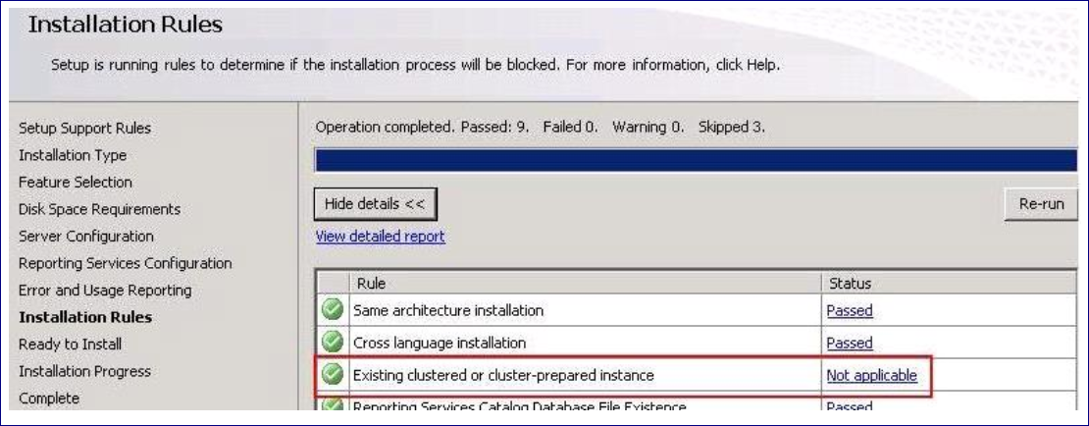

Now this time you can see the installation rule check passes without an error, because we skipped the installation rule process to make this installation possible.
Step 5: Here we can see the “Next” button is enabled, so click on Next to install SQL Server Reporting services on the active node.
Step 6: Once you are done with the installation on the active node (Node 1), follow the same process on each of the other nodes in the cluster.

